Developer Reference Guide

Contents

Caution 1

Excel Template Macros (API) 1

Creating New Excel Template or Update existing template 2

DCom Configuration 3

Web Server Configuration 5

Changing Server Password 6

Kill Orphan Excel Processes 6

User Permissions 6

Troubleshooting 6

# Caution

* Don’t open Excel file on server when Dcomconfig is set. This will hang the client excel. See in troubleshooting on how to resolve this issue
* For creating macros and new server template always use Excel 2013 64 bit (same version at the server version). This will ensure no compatibility errors when copying server template.

# Excel Template Macros (API)

NTVXModule is shared by both client and server. So they should have same code. Ensure the module code is same on all excel files (client and server)

On the server side NTVXModule exposes one public macro ServerProcess which is used internally by MVC.

On the client side NTVXModule exposes two macros that can be used to send a request to the web server and paste the data that is received by the web server

The two public Macros used in client excels are

* **HttpRequest**

This macro sends request to the web server with all the data from the client excel. It also parses the XML data received from the web server

This macro takes the following inputs:

* + templateFile: file name of the excel template on the web server that needs to opened
  + copySheetsAndRanges: how to copy client excel data on to server excel

format: "Client Sheet Name~Client Excel Range~Server Sheet Name~Server Start Cell;.....

example format: "Input1~A1:C7~LinkB~B1;Input2A~C5:T8~LinkB~P1"

the above format means the following:

Input1~A1:C7~LinkB~B1 :-

From Client Excel, copy Input1 sheet, range A1 to C7 to Server LinkB sheet at B1

Input2A~C5:T8~LinkB~P1 :-

From Client Excel, copy Input2A sheet range C5 to T8 to server LinkB sheet at P1

* + macroToExecute: name of the macro that needs to be executed on the server excel
  + returnSheetsAndRanges: this is semicolon delimited excel sheets and ranges that need to be brought from server on to client in xml

format: SheetName~ExcelRange (optional);SheetName~ExcelRange ....

example format: "FinModel~A1:C7,E10:J18;BuyerROI~A1:H20;ROI"

for the above format the following will be included in the XML

FinModel~A1:C7,E10:J18 :- In FinModel sheet Ranges A1:C7 & E10:J18

BuyerROI~A1:H20 :- In BuyerROI sheet A1:H20

ROI :- Entire ROI sheet as no range is specified

* + Returns: Parses the xml string returned by the server and populates the global xml dictionary. After this use PasteSheetRange to copy parts of the server excel sheet range on to client excel sheet range
* **PasteSheetRange**

This macro is to copy the data from the server (which is in xml format) to the client excel. This is also used on server side. This macro internally uses the server xml data which is parsed and stored in global variable xmlDictionary

This macro takes the following inputs:

* + serverSheetName: The name of the sheet on the server. This is coming from the xml
  + serverRange: The cell range on the server to copy the data. This data comes from xml
  + clientSheetName: Name of the sheet on the client onto which server data to be copied
  + clientStartCell: the starting cell to copy the server data

On the server side the public macro is:

* **ServerProcess**

This macro is used to process the data and instructions sent from the client. This is invoked from MVC application. For detailed description of parameters check the HttpRequest sub above

This macro takes the following inputs:

* + inputXmlString - Client excel values converted to xml and sent to server
  + copySheetsAndRanges - copy the data from xml (client excel data) on to the server excel sheet/range. format "clientSheet-clientRange-serverSheet-serverStartCell;.....
  + macroToExecute: name of the macro that needs to be executed on the server excel
  + returnSheetsAndRanges - list of sheets and ranges to be converted to xml and send back to client. Format - "FinModel-A1:C7,E10:J18;BuyerROI-A1:H20;ROI"

# Creating New Excel Template or Update existing template

When creating a new excel template copy the NTVXModule on to the template. The NTVXModule should be included in all excel files (both client and server).

Use Excel 2013 64 bit for creating and updating Excel template file. This will ensure there are no compatibility errors.

Steps for copying new or updated excel template

1. Give necessary permissions for the excel template and all the macros inside that template file
2. Ensure the excel template has NTVXModule
3. Using DCom Config (see below) set the identity to “The interactive user”
4. Copy the template on to web server location C:\inetpub\wwwroot\Excel\Templates
5. Open the Excel template on the server and click “Enable Content”
6. Save the Excel template on the server
7. Restart IIS (iisreset)
8. Using the client excel call the server template/macro (testing). If there are errors in the server macro (like reference errors) the excel debug will be opened on the server. Fix the errors and save and close the template.
9. Using DCom Config set the identity to “This User”
10. Restart IIS (iisreset)
11. Call the template from the corresponding client file to verify that it is working

# DCom Configuration

To run Excel under IIS, Excel identity should be configured in DCom. Here are the steps to configure DCom identity

* Run the dcomcnfg commad

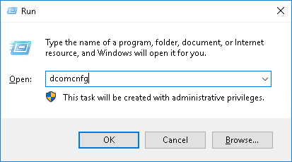

* Navigate to Component Services -> My Computer -> DCOM Config

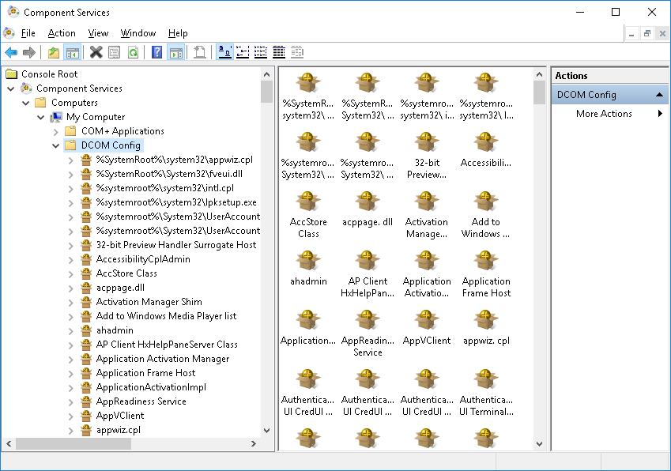

* Locate “Microsoft Excel Application” and right click and then click Properties

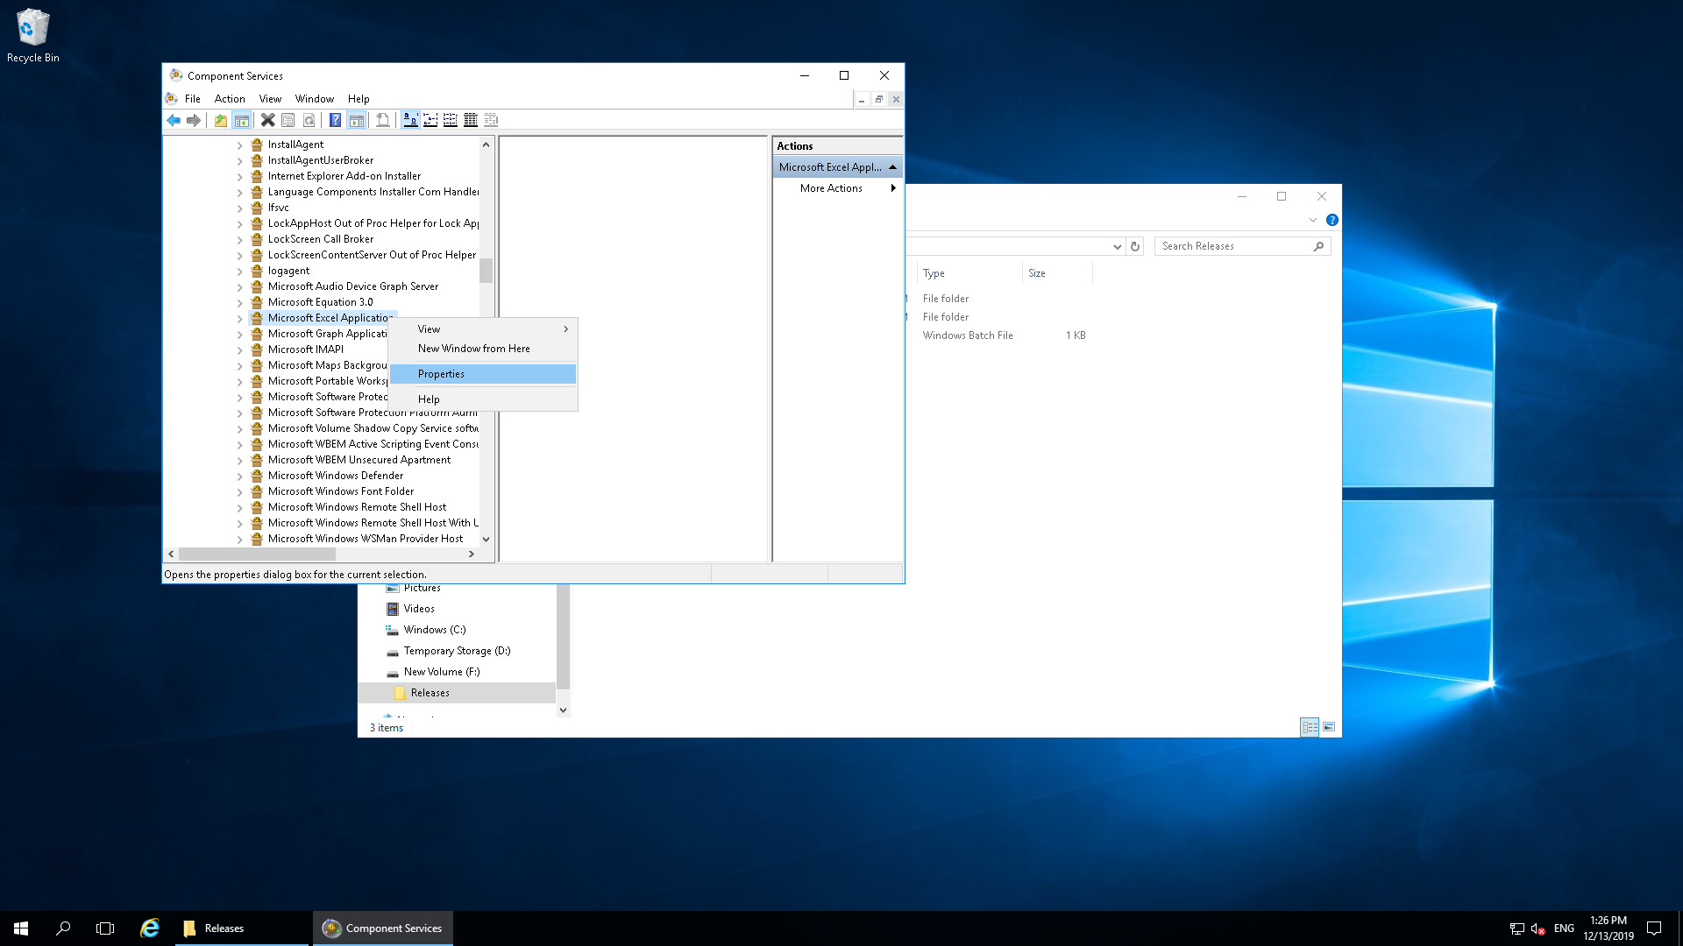

* In the properties window go to Identity tab

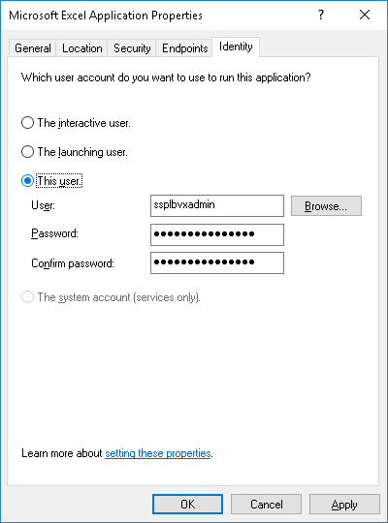

* Under Identity tab select “This User” option and provide ssplbvxadmin username and password
* To reset the Identity, select “The interactive user”

# Web Server Configuration

* For the DefaultAppPool (or the App Pool used by the NTVX API) set the Identity as ssplbvxadmin

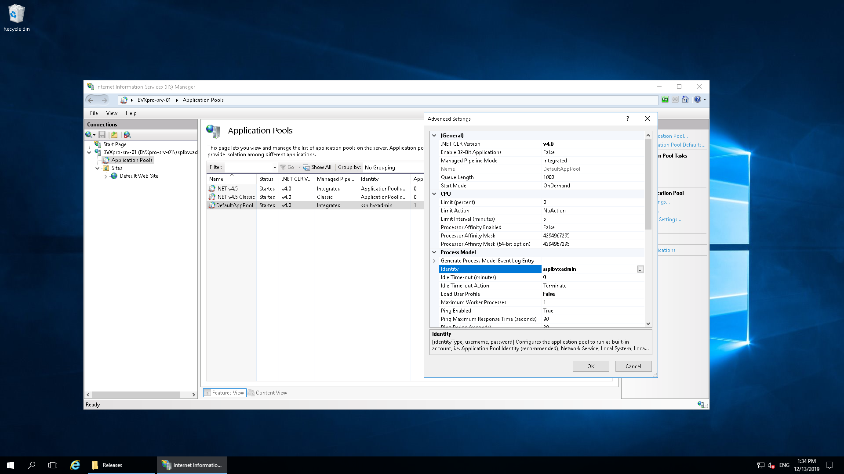

* The web server code is placed under C:\inetpub\wwwroot

# Changing Server Password

ssplbvxadmin user account is used in the following two places

* IIS Application pool
* DCOM configuration for Microsoft Excel Application Identity

When ssplbvxadmin password is changed, make sure the new password is updated at the above locations

# Kill Orphan Excel Processes

Whenever there is an error while opening and closing excel on the server, the Excel instance will be left over. This can be observed in Task Manager where we can see list of Excel. In this case, run the batch file F:\Releases\KillExcel.bat. This terminates the orphan excel processes and also deletes the excel files in C:\inetpub\wwwroot\Excel.

If there are errors while running the bat file, run it couple of times.

# User Permissions

Using admin control panel (to be developed by Sarjen) give permissions to the user.

Alternatively you can give permissions in the PermissionMst database table

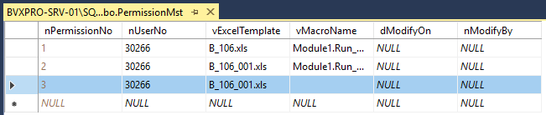

# Troubleshooting

|  |
| --- |
| Error: Client Excel hangs with no response from server |
| Resolution: This happens when you open the excel on the server when dcomcofig is set. To resolve this follow the steps:   * Open DCom config and change the identity to “The interactive user” * Open the excel template that is causing the hang * Close the excel template * Open the DCom config again and change the identity to “This User” * Go to the command prompt and restart the IIS (iisreset) |

|  |
| --- |
| Error: Retrieving the COM class factory for component with CLSID |
| Resolution: The server remote desktop session should be disconnected (not logged off). Log into the server and disconnect the session. |

|  |
| --- |
| Error: Microsoft Excel cannot access the file |
| Resolution: Restart IIS (iisreset) |

|  |
| --- |
| Error: When opening excel you get error “Cannot use object linking and embedding” |
| Resolution: This happens when you are trying to open excel on the server without disabling DCom Config. Don’t do this.  Follow the resolution for the issue “Client Excel hangs with no response from server” |